**Cloud Formation**

**Problem Statement:**

You work for XYZ Corporation. Your team is asked to deploy similar architecture multiple times for testing, development, and production purposes. Implement CloudFormation for the tasks assigned to you below.

**Tasks To Be Performed:**

1. Create a template which can create an S3 bucket named “Intellipaat-”

2. The template should be able to enable versioning for the bucket created.

Write a code to create S3 Bucket using yaml (I have used visual studio code)

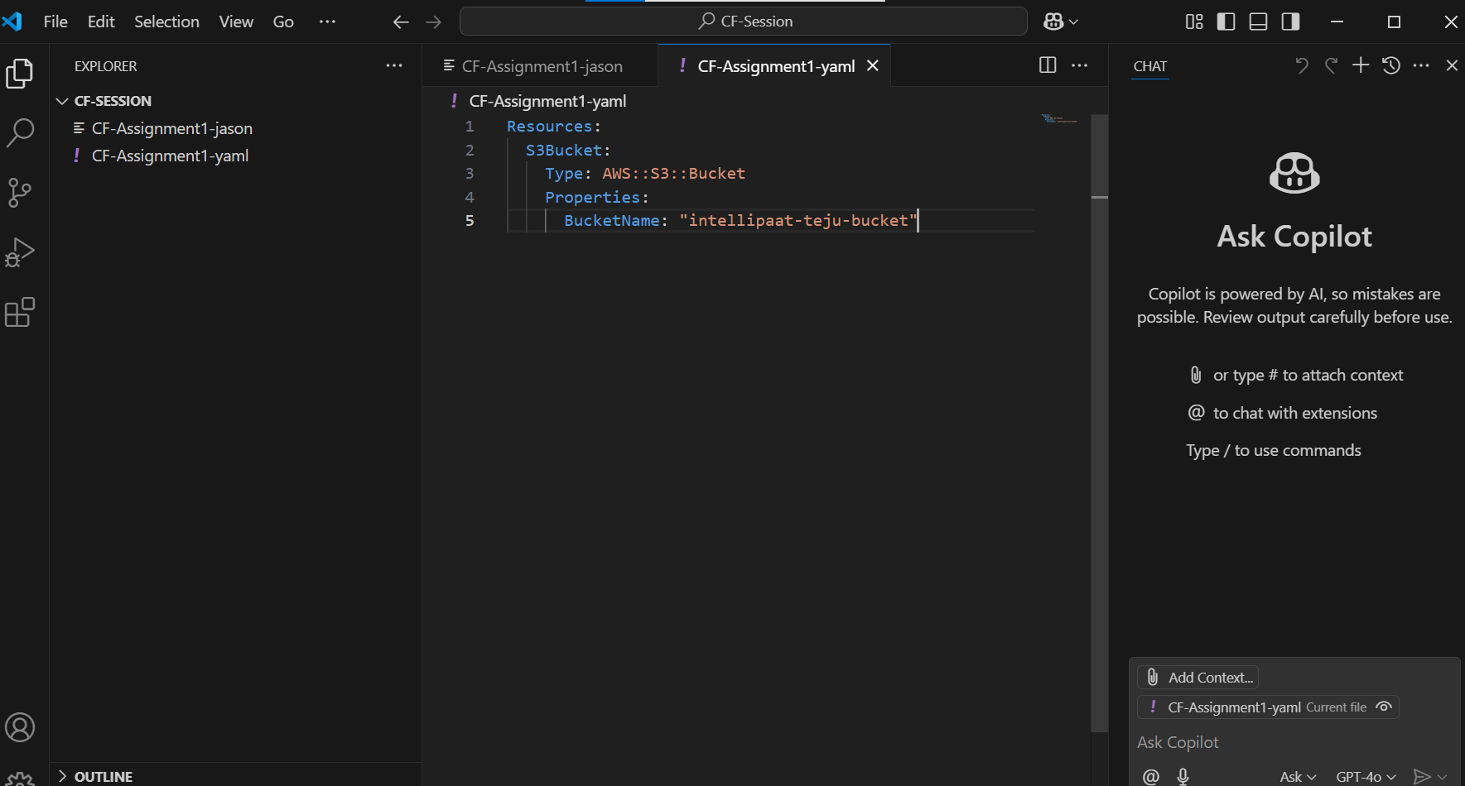

Create a stack using the above template

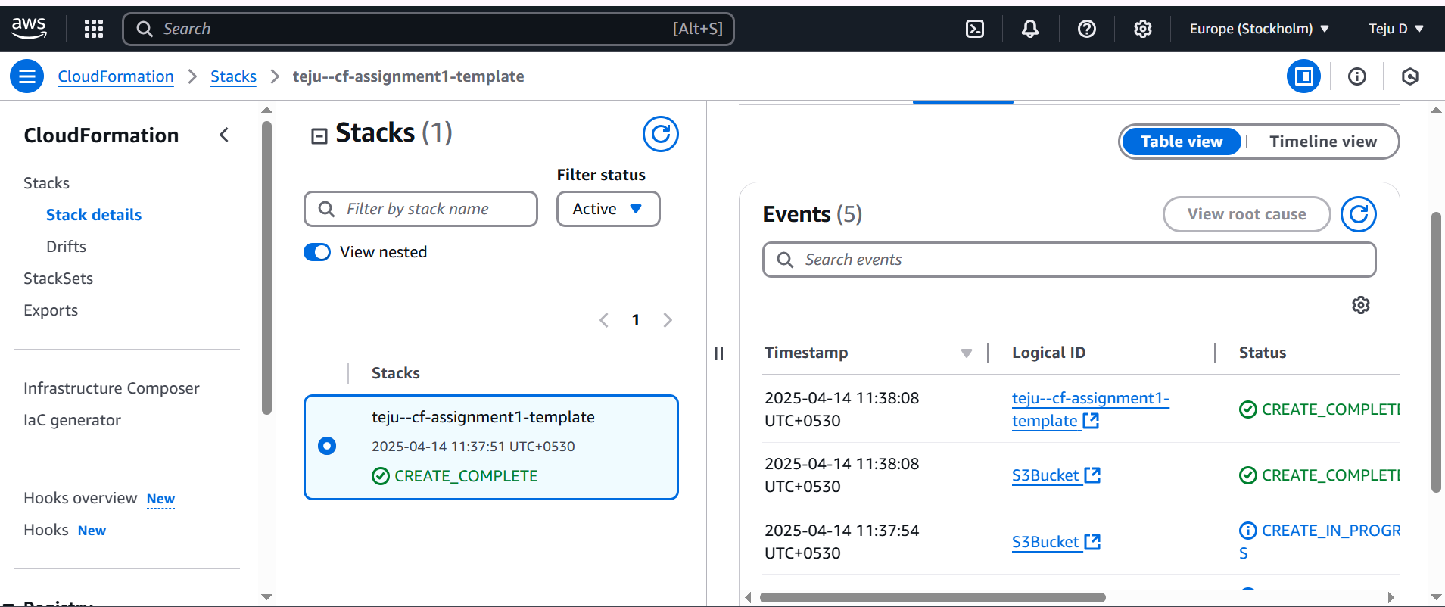

Since there is no bucket versioning enabled, go to the stack- click on the update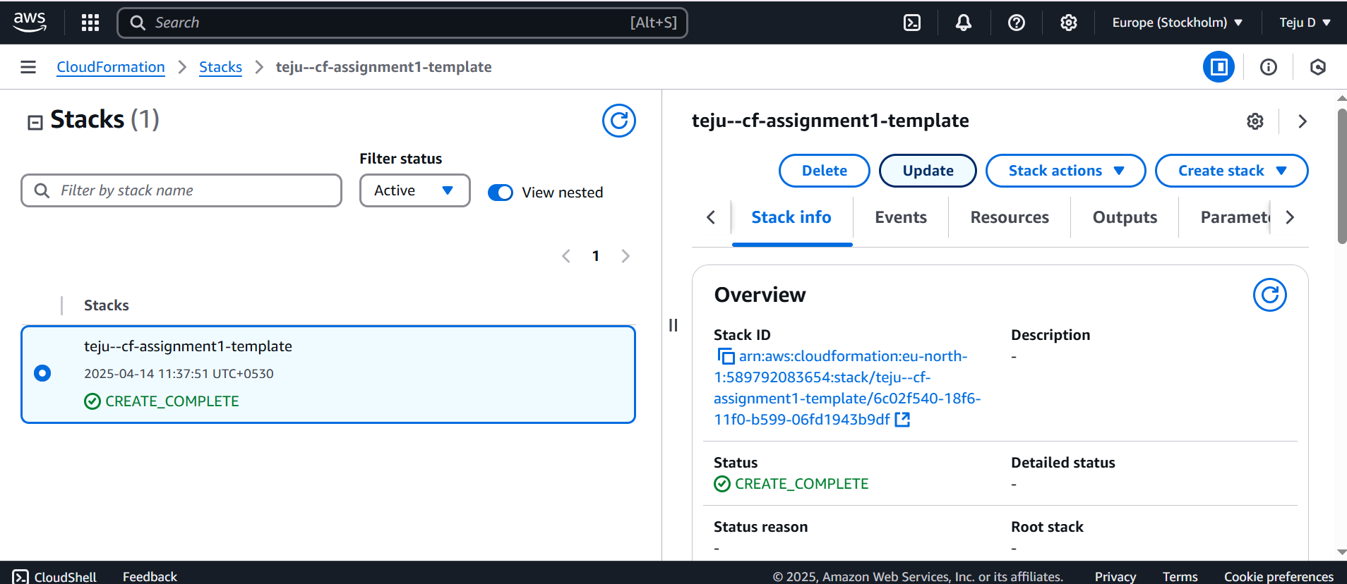

Add the updated code

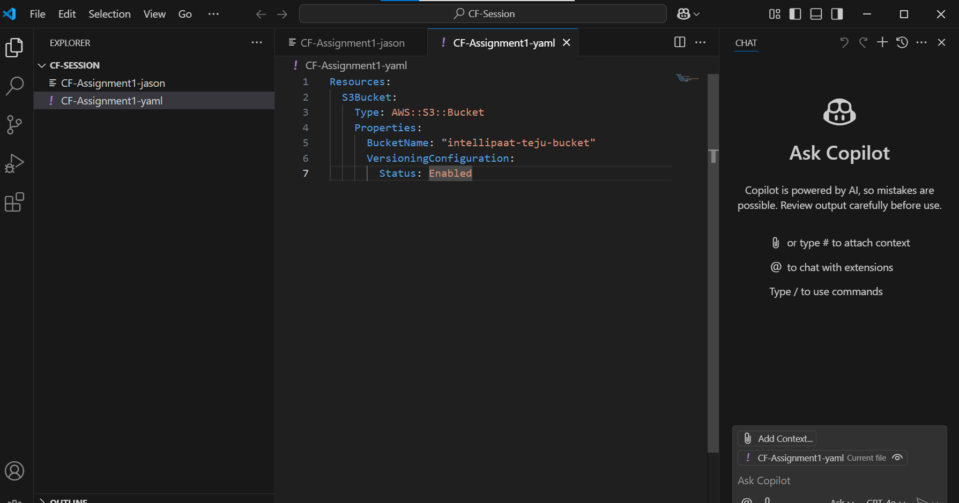

**Create a SNS Topic and an Email Subscription to the topic**